**DAILY ONLINE ACTIVITIES SUMMARY**

|  |  |  |  |  |  |  |  |  |
| --- | --- | --- | --- | --- | --- | --- | --- | --- |
| **Date:** | **13/06/2020** | | | | | **Name:** | **POOJA D S** | |
| **Sem & Sec** | **4th Sem 'B' Section** | | | | | **USN:** | **4AL18CS056** | |
| **Online Test Summary** | | | | | | | | |
| **Subject** | | **Data Communication** | | | | | | |
| **Max. Marks** | | **30** | | **Score** | | | **22** | |
| **Certification Course Summary** | | | | | | | | |
| **Course** | **Introduction to Ethical Hacking** | | | | | | | |
| **Certificate Provider** | | | **Great Learning Academy** | | **Duration** | | | **4.0 hour** |
| **Coding Challenges** | | | | | | | | |
| **Problem Statement:** A user will input two strings, and we find if one of the strings is a sub sequence of the other. Program prints “yes” if either the first string is a sub sequence of the second string or the second string is a sub sequence of the first string. Assume that, the length of the first string is smaller than or equal to the length of the second string. Assume that, the length of the first string is smaller than or equal to the length of the second string. | | | | | | | | |
| **Status: completed** | | | | | | | | |
| **Uploaded the report in Github** | | | | | **yes** | | | |
| **If yes Repository name** | | | | | <https://github.com/dspooja/C-coding>  <https://github.com/dspooja/Java-coding> | | | |
| **Uploaded the report in slack** | | | | | **yes** | | | |

Online Test Details: (Attach the snapshot and briefly write the report for the same)

Certification Course Details: (Attach the snapshot and briefly write the report for the same)

Coding Challenges Details: (Attach the snapshot and briefly write the report for the same)

ONLINE TEST DETAILS:

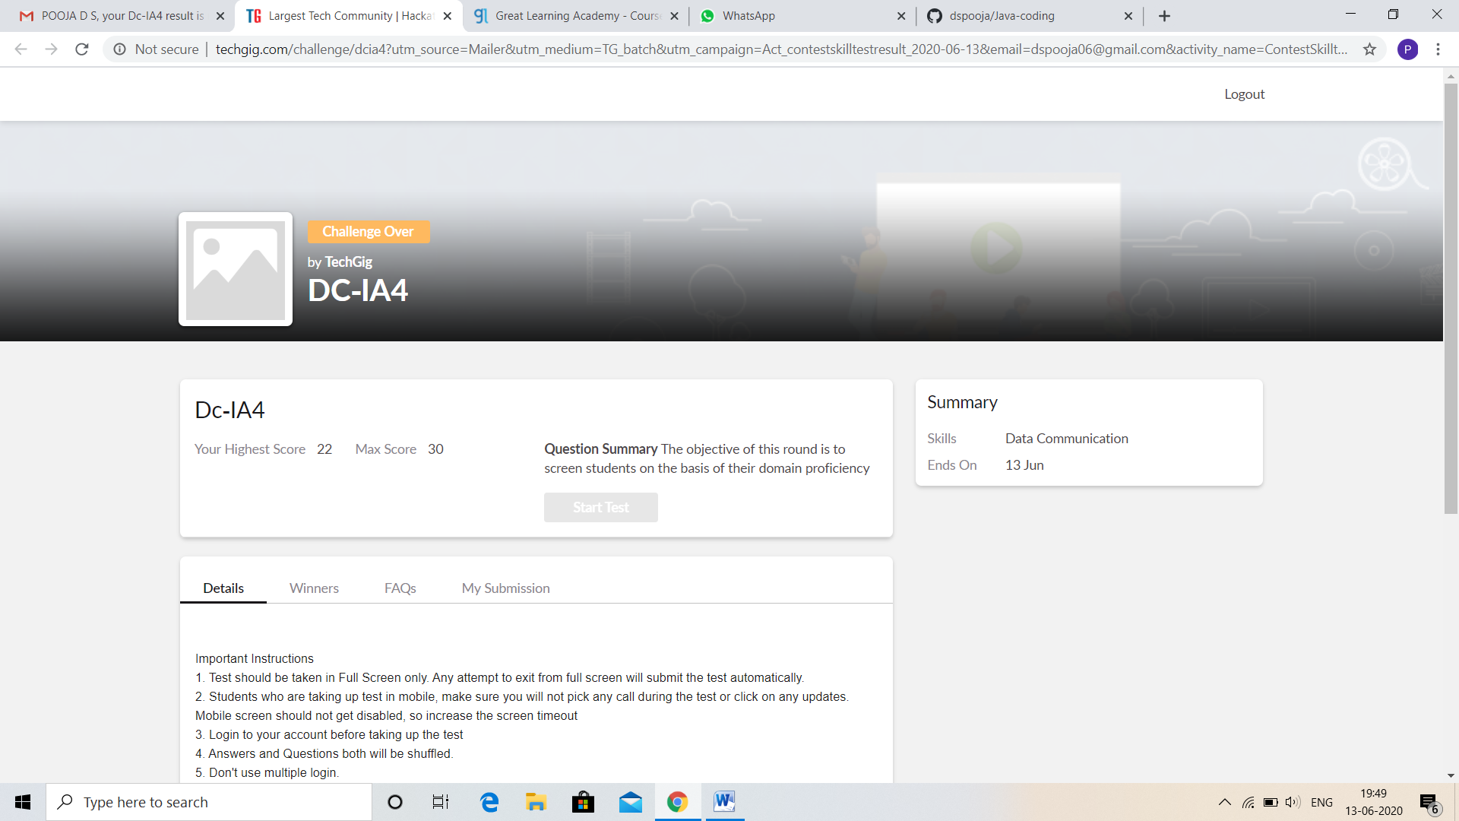

CERTIFICATION COURSE DETAILS:

* My Certification Course is **Introduction to Ethical Hacking**
* **The concepts covered in Introduction to Ethical Hacking are:**
* Ethical Hacking in Network Architecture-Demonstration.

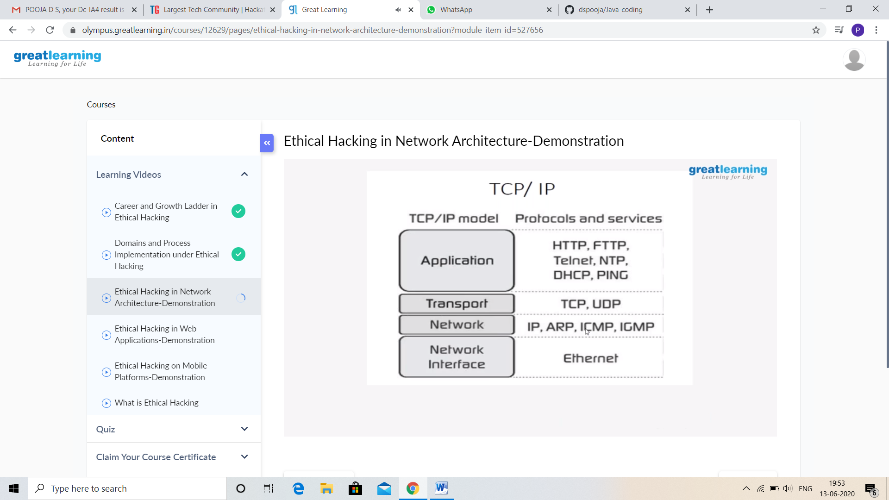

And I Participated and Secured 96% in E-QUIZ on Operating System. I got good Experience. And this is my certificate

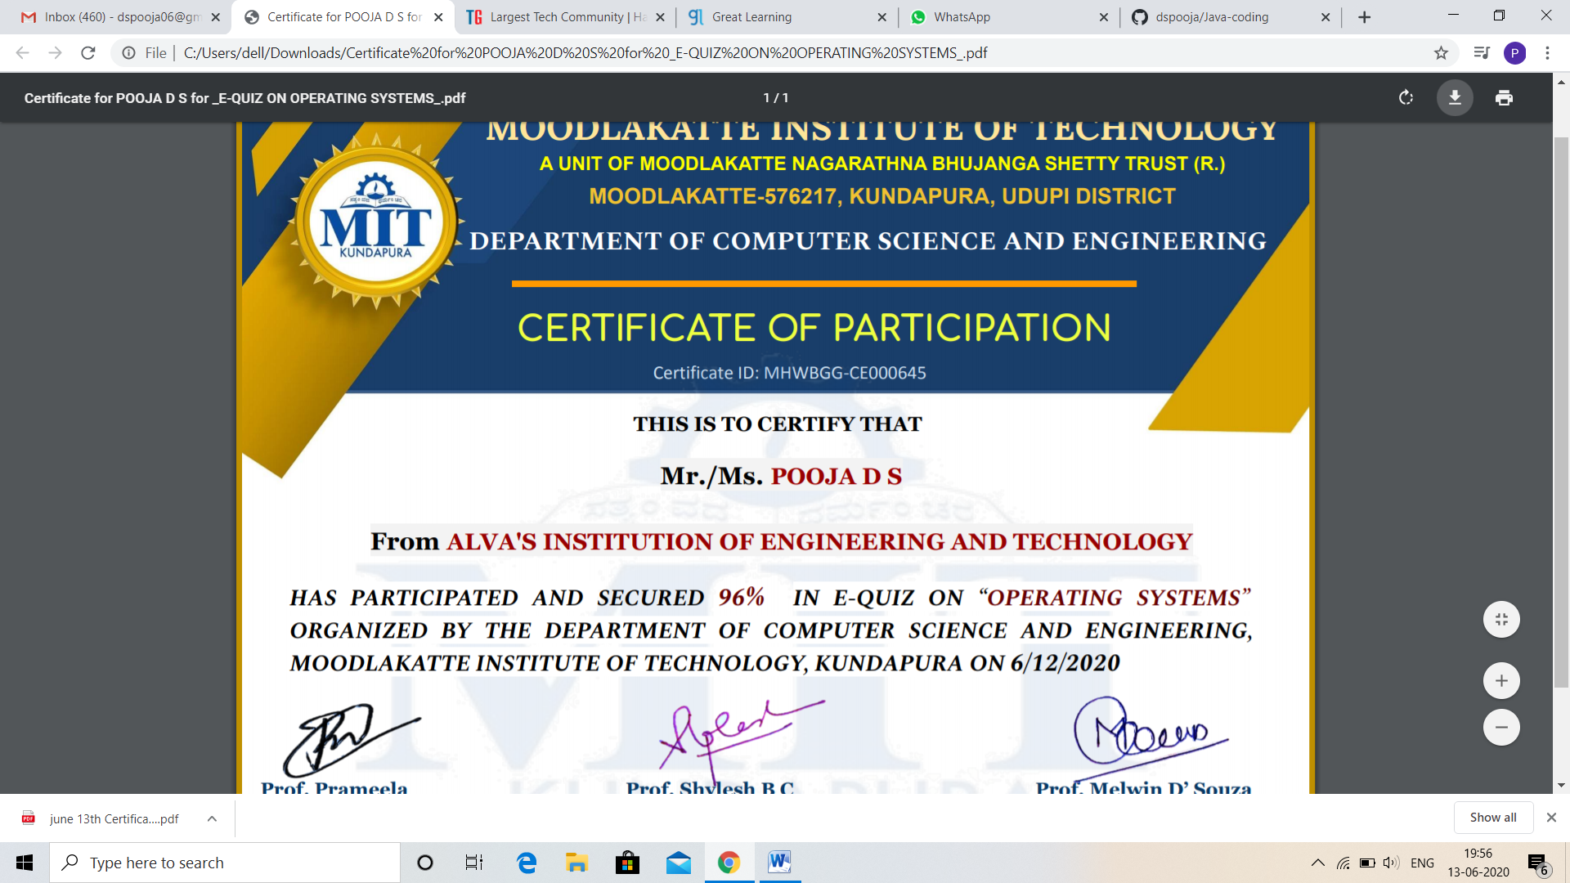

And I Successfully Completed the Quiz on “Python”. And this is my certificate.

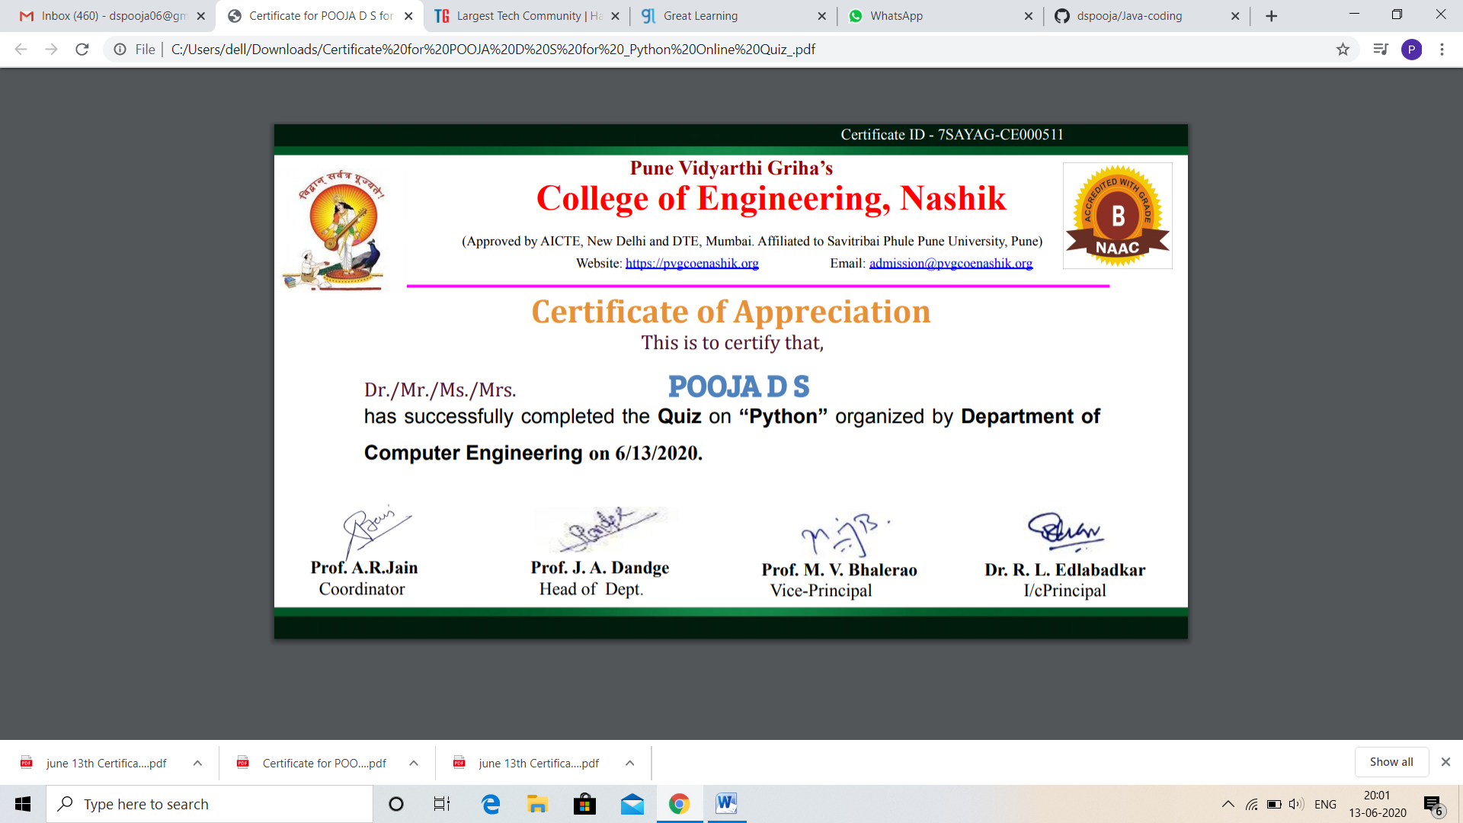

CODING CHALLENGES DETAILS:

Problem statement 1:

Write a C Program to calculate Electricity Bill.

Given an integer U denoting the amount of KWh units of electricity consumed, the task is to calculate the electricity bill with the help of the below charges:  
• 1 to 100 units – Rs 10/- Per Unit  
• 100 to 200 units – Rs. 15/- Per Unit  
• 200 to 300 units – Rs. 20/- Per Unit  
• above 300 units – Rs. 25/- Per Unit

**Examples:**

Input: U = 250

Output: 3500

Solution: Uploaded in github.

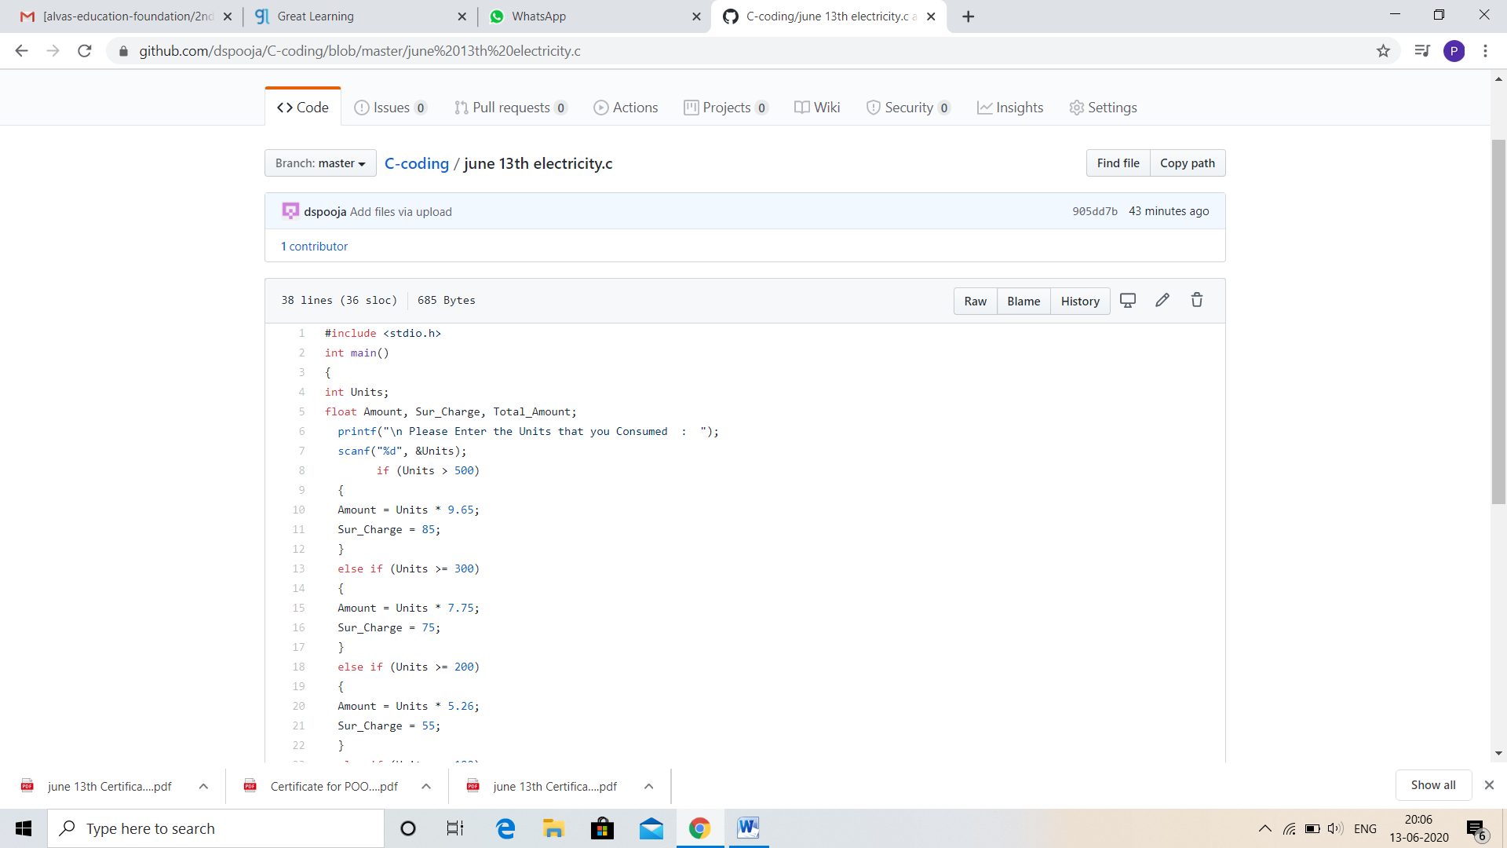

Problem statement 2:

How to find the first non-repeated character of a given String? Use Java and refer net

Solution: Uploaded in github.

